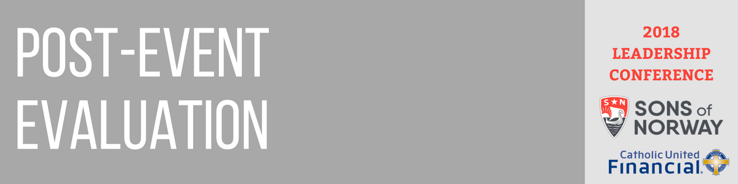

1. Did the event fulfill the intended purpose?
2. Did the event meet your goals? Why or why not?
3. What went well?
4. What can be improved?
5. Did the date and time work well?
6. Was the location a good fit?
7. Was the budget accurate?
8. Should anything be added or cut for future events?
9. If vendors were used, who were they?
   1. Would we use them again?
   2. Why or why not?
10. How did we work together as a team?
11. Any other comments or suggestions for holding this event in the future:

**Evaluation**

**Event** **Details**

**Name of Event: Date of Event: Location of Event:**

**Description:**

**Purpose of the event:**