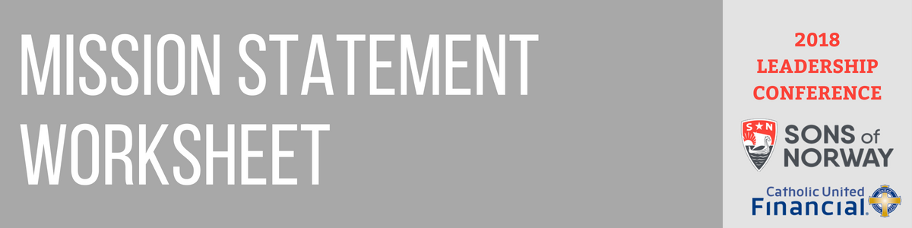

**Mission Statement:**

**Priorities from all the ideas above, single out your top priorities and defining traits**

**Discussion Questions – use these for brainstorming! Continue back if you need more room.**

Who are we?

What do we want to do?

Who do we want to help?

How will be benefit the world?

Why am I involved with this group?

Why do we exist?

What makes us different from other groups?

Your mission statement should be clear and simple. When you are finished, it should be easy to share this statement with others. Use this worksheet to help you identify your mission.