Perform the Mystery Night Plays at Your Lodge
Have fun entertaining your lodge and community by putting on one or more of these humorous Mystery Night plays. The plays offer a series of make believe events and mayhem at a fictional Sons of Norway lodge. The intent is to make you laugh at the over-the-top characters and celebrate our wonderful members, who most certainly do NOT act like the foolish and murderous folks in these plays.
Originally presented by the writer’s home lodge as dinner theater performances, you can choose whether or not your lodge will do this. The plays, with or without a dinner, could be great fundraisers for the Sons of Norway Foundation or your lodge scholarship program. You could also get together with another lodge in your district to perform it in your communities to entertain and attract prospective members. It’s completely up to you!
Your lodge prize package includes the enclosed Mystery Night play trilogy on a flash drive, so that you may customize the play and materials and print them out as needed. Later this year the plays will be made available to lodges on the Sons of Norway website.
Here’s what is included on the flash drive:
- Individual Word documents with the scripts for all three plays.
  - Murder at Sons of Norway Lodge I: The Beginning of the End
  - Murder at Sons of Norway Lodge II: Death Knocks Again
  - Murder at Sons of Norway Lodge III: The Ambassadors Come to Dinner
- Background and Guidance with tips and more information on how to successfully prepare for and present your Mystery Night plays.
- Promotional materials that you can display to advertise your event. These include:
  - A customizable art poster for each play. These charming, original posters were created specifically for each play. To customize the Word document with your event details like lodge name, play date, time and location; just add your information to the text box in the blank area of the posters.

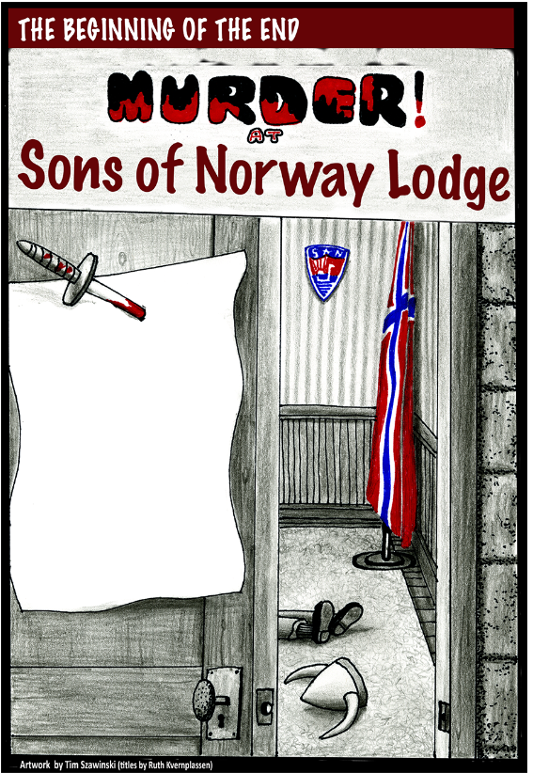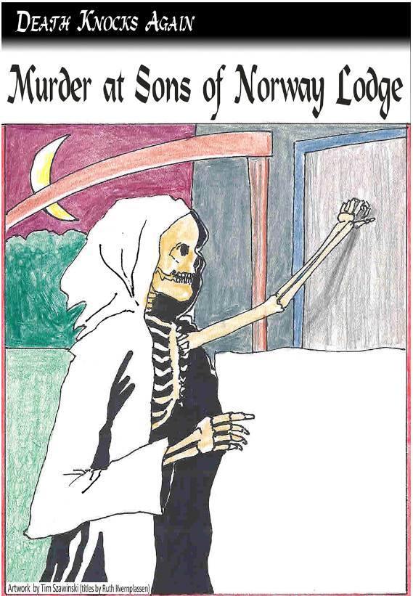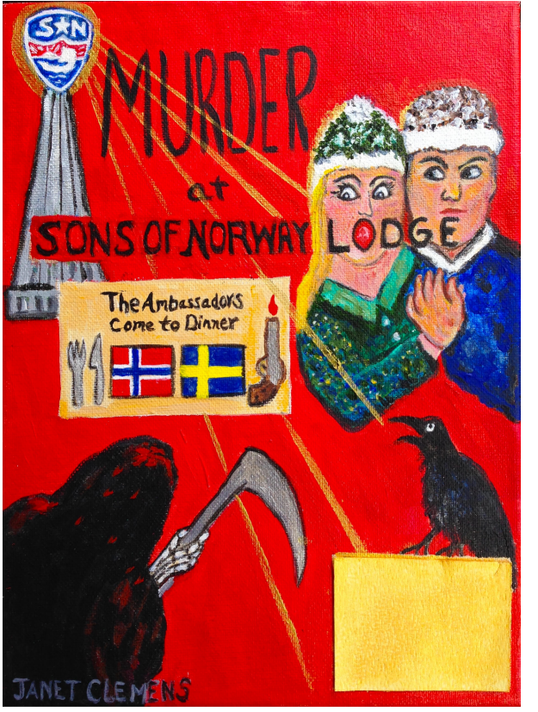
- Playbill fliers that you can hand out to promote the plays in your community or at other events. See examples below of the type of information you could include. These fliers can easily be edited in Word on sides 1 and 2. They are set up for duplex printing on an 8.5 x 11” sheet that can cut apart in the middle for your use.
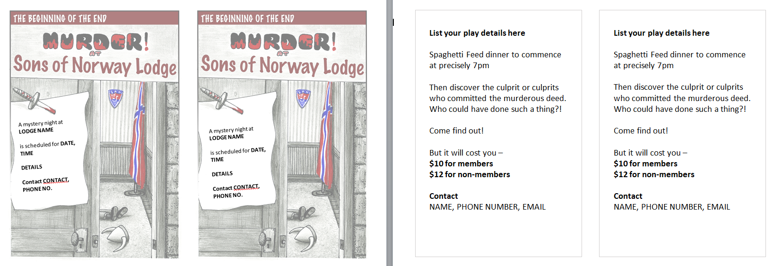
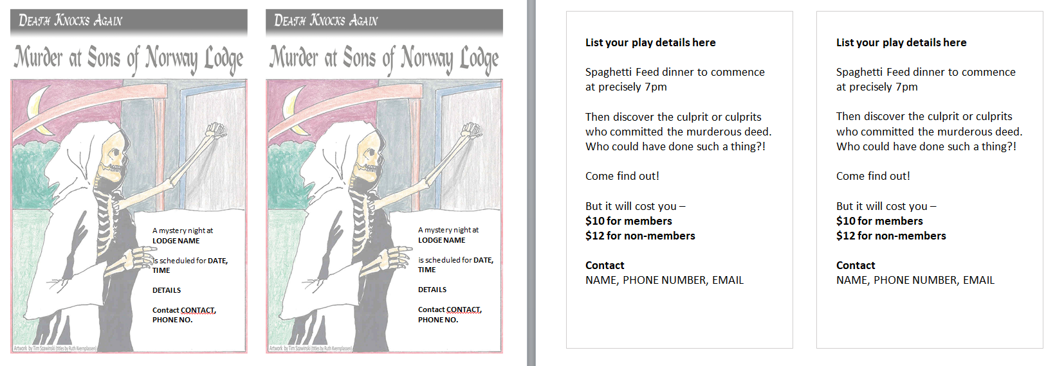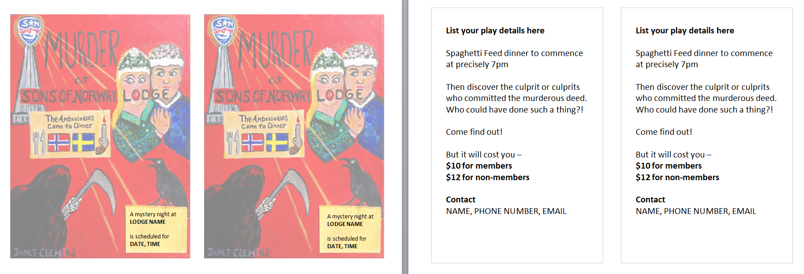
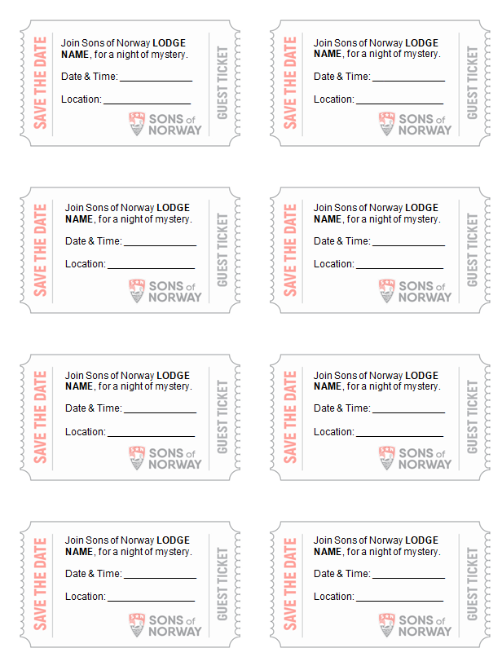
- A Ticket sheet that you can use if you are selling tickets and/or have limited audience space with assigned seating. The tickets can be customized by editing the Word document.

