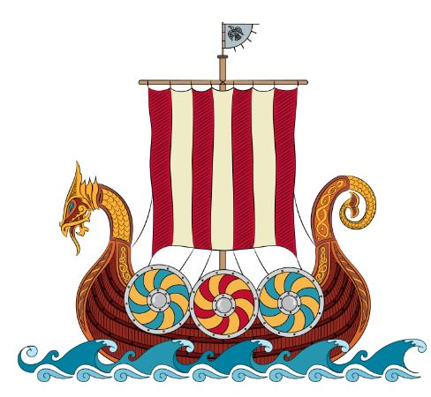
Join us for a Syttende Mai
Celebration!

WHO: The members of Vennelag Lodge, Mt. Horeb, WI
WHAT: Dinner and evening program, awards to follow
WHY: Celebrating Norwegian Constitution Day & Our Heritage
WHEN: Thursday, May 30, 2019, beginning at 6:30 PM
WHERE: Mt. Horeb Community Center, 107 N. Grove Street
Mt. Horeb, Wisconsin 53572
*If you choose, please bring a dish to share for the meal. Roast turkey, beverages, and dessert will be provided.

Vennelag Lodge is a proud Community partner, and we welcome your participation.
Alle er Velkommen!
TAKK!

