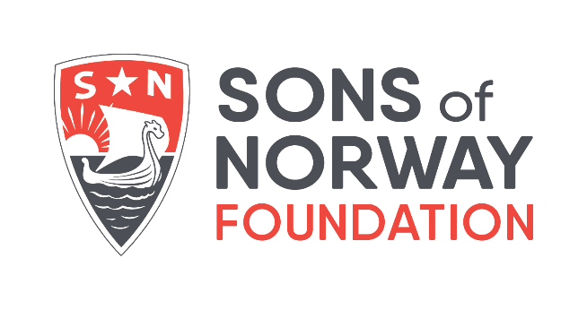
Lodge Donation Form

Lodge Name (ex. Draxten): __________________________________ District and Lodge # (ex. 1-464): _______________
Contact Name and Title: ______________________________________________________________________________
Address: _______________________________________ City: ________________________ State: _____ Zip:_________
Phone: ______________________________ Email: ________________________________________________________
Enclosed is my lodge’s donation to the Sons of Norway Foundation for $ _____________
How funds were raised (ex. Silent auction, bake sale, etc.) and any other comments: _____________________________
__________________________________________________________________________________________________
__________________________________________________________________________________________________
Member Donations: (Note: member donations are only tax deductible if paid directly to Sons of Norway Foundation. Member and/or lodge donations of $100 or more will be recognized in the Sons of Norway Foundation annual report.)
Member Name | Email | Member # | $ Amount
Please use additional sheets if necessary. Return form along with checks made out to:
Sons of Norway Foundation, Attn: Anne Olson, 1455 W Lake St., Minneapolis MN 55408
or email to foundation@sofn.com and give online at www.sofn.com/foundation
Thank you for your support of the Sons of Norway Foundation!

